AI-Based Fake News Detection System Using Machine Learning
Sahil  Department of Computer Science and Engineering  Chitkara University Institute of  Engineering and Technology,  Chitkara University  Rajpura, Punjab, India sahil2211.be22@chitkara.edu.in | Sachin Kumar  Department of Computer Science and Engineering  Chitkara University Institute of  Engineering and Technology,  Chitkara University  Rajpura, Punjab, India sachin2204.be22@chitkara.edu.in

Abstract
The rapid growth of digital media platforms has significantly increased the spread of misinformation and fake news. Traditional manual verification methods are time-consuming and inefficient for handling large volumes of data. This paper presents an AI-based Fake News Detection System using machine learning and Natural Language Processing (NLP) techniques. The system preprocesses textual data using tokenization, stop-word removal, and stemming, followed by TF-IDF vectorization for feature extraction. Multiple machine learning models, including Logistic Regression, Random Forest, and Gradient Boosting, are trained and evaluated. Experimental results demonstrate that ensemble models, particularly Gradient Boosting, achieve the highest accuracy (95%) and better generalization. The proposed system provides an efficient and scalable solution for detecting fake news and reducing misinformation in digital environments.
Keywords—Fake news detection, machine learning, NLP, TF-IDF, Logistic Regression, Random Forest, Gradient Boosting, misinformation, text classification.

I. INTRODUCTION  The widespread use of social media and online news platforms has significantly transformed the way information is shared and consumed. Today, news can reach millions of people within seconds, making communication faster than ever. However, this rapid dissemination of information has also led to the uncontrolled spread of fake news. Fake news refers to false or misleading information presented as genuine news, often created to influence public opinion, gain financial benefit, or create confusion in society.  The impact of fake news is becoming increasingly serious. It can mislead individuals, affect decision-making, and create social, political, and economic instability. For instance, fake news during elections can influence voters, while misinformation in healthcare can lead to harmful consequences. Due to the large volume of digital content generated daily, manually verifying the authenticity of every news article is nearly impossible.  In earlier times, fake news could be identified through manual verification or obvious indicators  Deep learning models such as LSTM and BERT have also been explored, though they require significantly more computational resources.  Our work builds upon these existing approaches by implementing and comparing three classical ML models—Logistic Regression, Random Forest, and Gradient Boosting—on a publicly available Kaggle dataset, providing a systematic evaluation framework for fake news detection.  III. OBJECTIVES  • Automated Detection: Develop a fake news detection system using machine learning.  • NLP Preprocessing: Apply tokenization, stop-word removal, and stemming.  • TF-IDF Vectorization: Convert textual data into numerical feature vectors.  • Multiple ML Models: Implement and compare Logistic Regression, Random Forest, and Gradient Boosting.  • Performance Evaluation: Assess models using accuracy, precision, recall, and F1-score.  • Best Model Selection: Identify the most effective model for reliable classification.  • Scalability: Provide an efficient solution applicable to large-scale digital content.  IV. DATASET  A labeled dataset containing real and fake news articles was collected from public sources such as Kaggle. The dataset contains approximately 44,000 articles with two classes: REAL and FAKE. The distribution is nearly balanced as shown in Fig. 3, with approximately 52% real news and 48% fake news, ensuring that the trained models are not biased toward any single class.  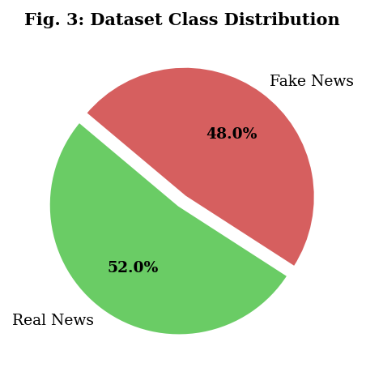  Fig. 1 Dataset Class Distribution  C. ML Classification Models  • Logistic Regression: Baseline linear classifier for binary fake/real classification.  • Random Forest: Ensemble of decision trees using bagging strategy.  • Gradient Boosting: Sequential ensemble model that corrects errors iteratively.  VI. RESULTS AND ANALYSIS  A. Classification Accuracy  Table I presents the overall accuracy of each model, and Fig. 1 shows a visual bar chart comparison.  TABLE I. MODEL CLASSIFICATION ACCURACY  Model Accuracy (%)  Logistic Regression 85%  Random Forest 92%  Gradient Boosting 95%  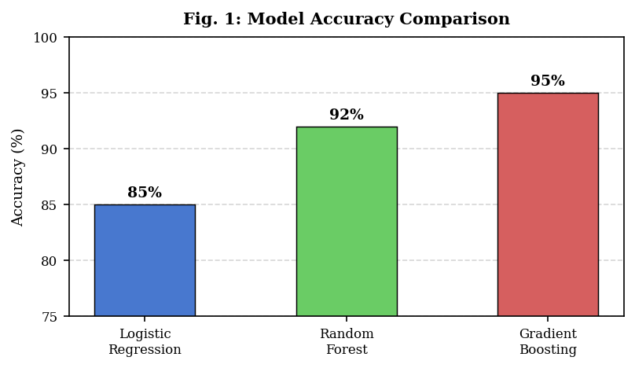  Fig. 3: Model Accuracy Comparison (%)  B. Precision, Recall & F1-Score  Table II and Fig. 2 present detailed performance metrics for all models across precision, recall, and F1-score.  TABLE II. DETAILED PERFORMANCE METRICS  Model Accuracy Precision Recall  Logistic Regression 85% 83% 84%  Random Forest 92% 91% 90%  Gradient Boosting 95% 94% 95%  architectures such as LSTM, CNN, or transformer-based models to improve robustness.  VIII. CONCLUSION  This study demonstrates that machine learning and NLP techniques are effective for detecting fake news in digital environments. The proposed system applies a complete pipeline—text preprocessing, TF-IDF feature extraction, and ML classification—achieving a maximum accuracy of 95% with Gradient Boosting.  The system provides a scalable and automated solution for misinformation detection, overcoming the limitations of traditional manual verification approaches. In future work, deep learning models such as LSTM and BERT-based transformers will be integrated to further enhance accuracy and contextual understanding.  REFERENCES  [1] Kaggle Dataset for Fake News Detection. [Online]. Available: https://www.kaggle.com/  [2] F. Pedregosa et al., "Scikit-learn: Machine Learning in Python," J. Mach. Learn. Res., vol. 12, pp. 2825–2830, 2011.  [3] S. Pal et al., "Applying Machine Learning to Detect Fake News," Intl. J. Comput. Sci., 2019.  [4] A. Nigam et al., "Fake News Detection Using NLP Techniques," IEEE Access, vol. 9, 2021.  [5] UCI Machine Learning Repository. [Online]. Available: https://archive.ics.uci.edu/  [6] A. Vaswani et al., "Attention Is All You Need," in Proc. NeurIPS, 2017.  [7] J. Devlin et al., "BERT: Pre-training of Deep Bidirectional Transformers," in Proc. NAACL, 2019. |  | such as grammatical errors, sensational headlines, or unreliable sources. However, with the advancement of Artificial Intelligence and automated content generation, fake news has become more sophisticated. Modern fake news articles are often well-structured and difficult to distinguish from real news.  This research focuses on developing an AI-based Fake News Detection System using machine learning techniques. By applying NLP methods and classification algorithms, the system aims to accurately identify fake news and reduce the spread of misinformation in digital platforms.  II. BACKGROUND & RELATED WORK  Fake news has been studied extensively in the context of natural language processing and information retrieval. Early approaches relied on rule-based keyword matching and manual fact-checking, which were slow and not scalable. More recent methods leverage supervised machine learning with handcrafted features such as TF-IDF, word count, and sentiment scores.  Pal et al. [3] demonstrated that Logistic Regression applied on TF-IDF features achieved around 85% accuracy on benchmark datasets. Nigam et al. [4] extended this by incorporating ensemble methods, achieving above 90% accuracy.  V. METHODOLOGY  The proposed system follows a structured machine learning pipeline for detecting fake news, as illustrated in the flowchart (Fig. 5).  A. Data Preprocessing  Raw text data is cleaned and normalized using the following NLP steps:  • Lowercase conversion: Normalize all characters to lowercase.  • Punctuation removal: Remove special characters and punctuation marks.  • Stop-word removal: Eliminate common words that carry no semantic value.  • Tokenization: Split text into individual word tokens.  • Stemming/Lemmatization: Reduce words to their root forms.  B. Feature Extraction (TF-IDF)  TF-IDF (Term Frequency–Inverse Document Frequency) converts processed text into numerical vectors, assigning weights to words based on their frequency and uniqueness:  TF-IDF(t, d) = TF(t, d) × log(N / DF(t))  where TF(t, d) is the term frequency in document d, N is the total number of documents, and DF(t) is the number of documents containing term t.  SYSTEM FLOWCHART  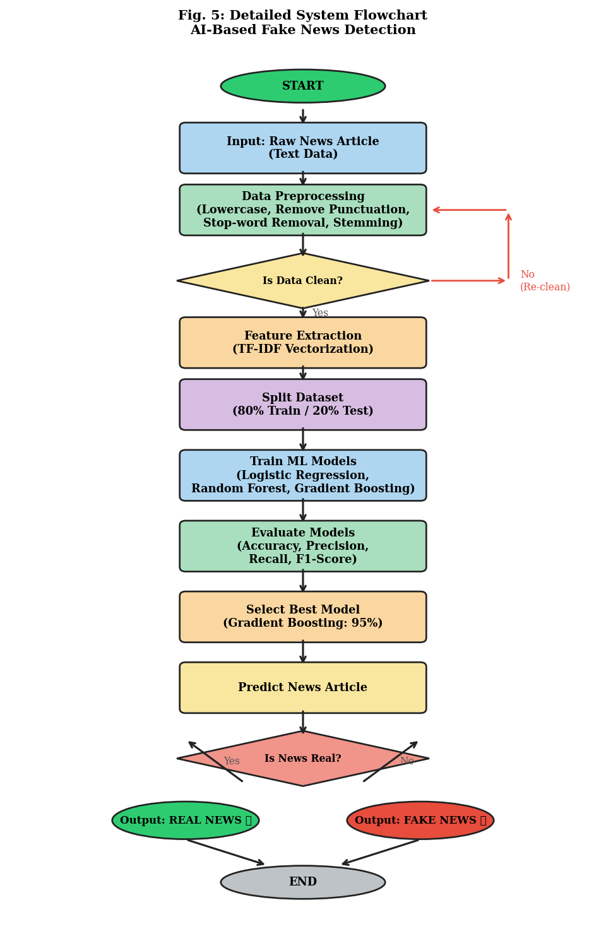  Fig. 2: Detailed System Flowchart for AI-Based Fake News Detection  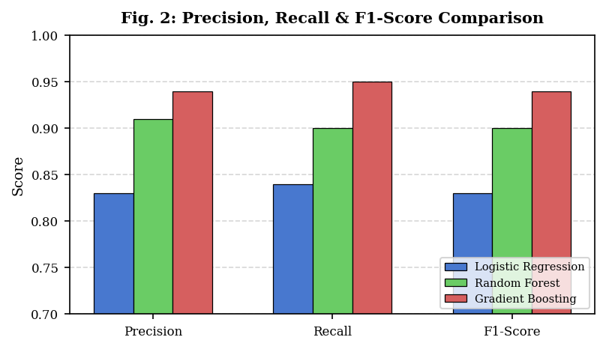  Fig. 4: Precision, Recall & F1-Score Comparison  C. Training vs Validation Accuracy  Fig. 4 shows the learning curve of Gradient Boosting across training iterations, demonstrating convergence with minimal overfitting.  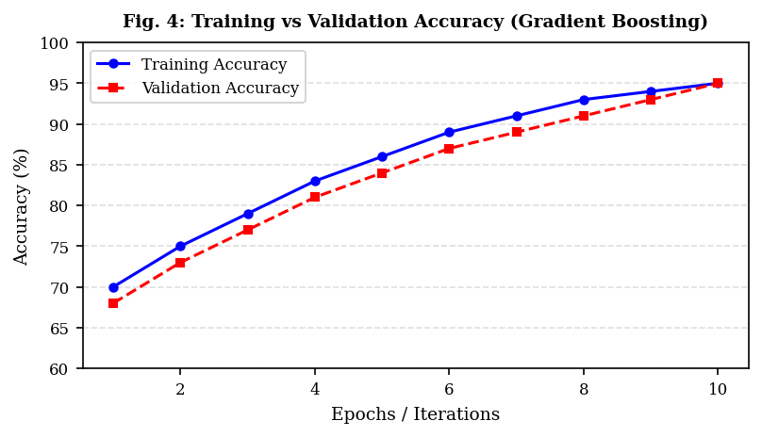  Fig. 5: Training vs Validation Accuracy (Gradient Boosting)  D. Comparison with Traditional Methods  Traditional keyword-based and manual verification methods achieve limited accuracy (~65-70%) and are not scalable. The proposed TF-IDF and ML pipeline significantly outperforms these baselines, and requires no manual intervention, enabling real-time detection at scale.  VII. DISCUSSION  The experimental results confirm that ensemble models outperform simple linear classifiers for fake news detection. Gradient Boosting achieves 95% accuracy by iteratively correcting classification errors, making it the best-performing model in this study.  The TF-IDF feature extraction approach effectively captures discriminative textual patterns between real and fake news. However, future work could explore contextual embeddings such as Word2Vec, GloVe, or BERT to capture semantic relationships beyond simple term frequencies.  A key limitation of the current system is its dependency on the quality and balance of the training dataset. Highly sophisticated AI-generated fake news may bypass the current model. Future enhancements should include deep learning

